

|  |
| --- |
| **Research**  **Strategy** |
| 2022 - 2030 |

# Background

UCEM’s ambition is to transform into a research-informed institution, as *the* ‘Centre for Excellence for Built Environment Education.’ With this, our central strategy, GLOBE, that will lead us up to 2030, will place sustainability at the center of our core purpose.

Achieving a better Built Environment is increasingly synonymous with a sustainable Built Environment. The ultimate impact UCEM strives to achieve is framed by the UN Sustainable Development Goals (UNSDGs), with our primary focus of activity on the SDGs to which UCEM’s core purpose most directly aligns, as well as demonstrating our Environmental, Social and Governance (ESG) credentials. Therefore, UCEM’s 2022-2030 Research Strategy is intended to form a reference point and provide the basis for the actions we take to ensure that research contributes fully to GLOBE’s objectives. It reflects our historical and current research position, and how we can improve upon this for the future.

Many actions set out in this strategy depend upon changes in the culture and processes in the School and in our Research Centre, and most importantly, as individuals. Therefore, widespread buy-in will be needed if this strategy is to be realised. It is also important that this Research Strategy is coordinated with other areas of the University, for teaching and enterprise. The overarching driver is a University, which is excellent in research and research impact, is far better equipped to meet and exceed the expectations of its students and wider stakeholders.

We have a clear intention to play a leading role in setting the built environment research agenda, nationally and internationally, through real-world focused research. Our aspiration is to build upon our reputation to deliver world-leading, co-created research that shapes built environments of the future. Our research has a global impact in supporting the creation of sustainable, resilient buildings that embrace ideas to improve the wellbeing and wider cultural lives of all their citizens.

We acknowledge the new fast-changing realities in our towns and cities. These developments are a result of the following:

* The reality of climate change
* The challenges and decline of infrastructure
* The emergence of ecology of cities
* The challenge of governance
* The economic turmoil
* Ageing population

With this, urbanisation is increasing at an alarming rate. The majority of towns and cities face ecological threats that require immediate intervention for survival. Climate change will soon reach a point in many places where the average coldest year will be hotter than the past 40 years (a climate departure point; the journal Nature projects that the whole world will pass the climate departure point in 2047). The need for a true circular economy has never been greater.

Disruptive innovations, largely relying on the significant advance in digital technologies, have already helped the sector achieve progress towards achieving sustainable, resilient, and more inclusive future-built environments. We therefore will position ourselves in a way to best deliver against these new realities. Staff are poised to generate concepts and solutions that are designed to create ideas, digital tools and new infrastructure, that all work together to deliver solutions for

new forms of living. In doing so, we aim to address the UNSDG agenda – our GLOBE strategy has the UNSDGs as its core.

UCEM encourages staff to engage with research and advanced scholarship within our Sustainable Built Environment and Property Research Centre; all staff are invited to be full members, or associate members. Our Research Centre places UN SDG goal 11 and 12 – of sustainable cities and communities, and of responsible consumption and production – as our central focus. Achieving a better built environment is synonymous with a sustainable Built Environment.

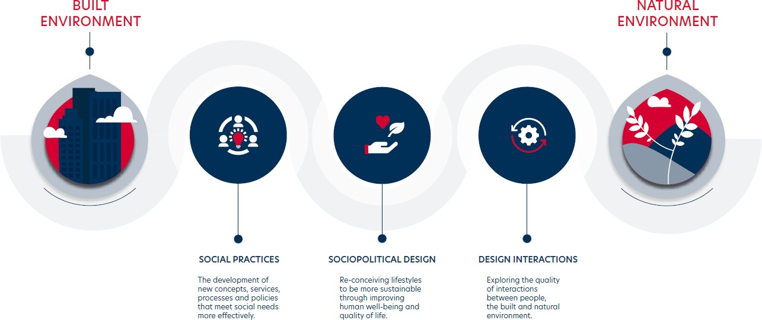

We have a firm commitment to grow the breadth and depth of our research, and this UCEM Research Strategy sets out a number of objectives:

|  |  |
| --- | --- |
| **Aim:** | **Success measure:** |
| Grow our research | * Research income. * High-quality research outputs. * Postgraduate Research (PGR) students. * Number/ proportion of staff capable of supervising PGR students. * Number/ proportion of staff engaged in research. |
| From participation to leadership | * External impact and influence, not limited to: number of conferences, seminars, workshops that UCEM convenes and attends etc.; staff sitting on editorial boards, membership of   global networks, advisory panels etc. |
| Drive impact and make change | * Research-informed curricular in all UG and PGT programmes. * Strategic partnerships established with leading organisations from academia and industry. * Numbers of co-produced/ collaborative research. * Numbers of interdisciplinary and multidisciplinary research * Potential of future Research Excellence Framework (REF) submission. |

We aim to do this by:

|  |  |
| --- | --- |
| **We will:** | **We will do this by:** |
| To provide a research culture and infrastructure that attracts and retains world-class academics. | * To become the location of choice for research excellent staff at all career stages. * To develop clear pathways for promotion through a supported workload balancing model. * Provision of research mentoring for staff. * To provide an environment that attracts and retains staff at the peak of their research careers. |

|  |  |
| --- | --- |
|  | * To ensure administrative support for research is integrated and supportive to maximise quality time to undertake research. |
| To provide a research environment that attracts and supports high quality postgraduate researchers (home- growing our own UCEM research active staff is key), with first class training, supervision and facilities. | * Offer research degrees with support from an accrediting partner, with the ambition of obtaining RDAP (Research Degree Awarding Powers) in the long term. * Extend supervisory capacity in areas of strategic importance for PGR growth. * Work closely with external institutions to support PhD activities; to collaborate in doctoral partnerships and projects. * Build on links with international university partners to support shared PhD activities, with the ambition of developing a doctoral school in future. |
| To publish high quality, impactful research | * Maintain the highest standards of rigour and integrity in all aspects of research. * Ensure the quality of our research is reflected by leading performance in any measures of quality that maybe applied, including international rankings and the REF, by publishing in leading outlets and attracting high levels of citations for the majority of our outputs. * Support the requirements of Open Access while taking account of the specific needs of our discipline. * Externalise our research, including the creation of a University repository. * To ensure our research has an impact beyond academia and yield economic, social and cultural benefits. |
| To be recognised both in the UK and internationally for the application of our research for the benefit of industry, commerce, government and society as a whole. | * To convene high-profile research focused events. * Leading in the development of wider debates around the role of the built environment in social, economic and environmental change. * Ensuring consistency of message in communicating our research agenda to externals. |
| To foster a research environment that supports Sustainability (GLOBE) and key research themes of UK Research Councils and addresses global challenges | * Develop strategically important areas of research growth. * Develop new areas of research collaboration informing our own subject research, but also redirecting the development of other disciplines. * Exploit our capabilities to form new and ground- breaking interdisciplinary combinations to address societal challenges. |
| To be a valued collaborator with UK and international businesses and industries through collaboration, partnerships and knowledge exchange. | * Create institutional partnerships, both internationally and within the UK. * Increase external funding for research through pre- application support; increased training for early and mid-career researchers in funding applications. * Develop the relationship of our research activities with SMEs, professions and international industry partners. |

|  |  |
| --- | --- |
|  | * Increase the visibility of our staff in national and international media forums. |